Project Coffee House

- Based on the theme that: for most users, it’s not immediately clear how to create a new sign-up, an insight is: The users need clear proper label for sign-up and they are confusing with label ‘Register Now’

- Based on the theme that: the 3 dot sub-menu is difficult to find for almost all users, an insight is: Users need a more intuitive way to access label settings.

- Based on the theme that: Users have difficulty knowing they have done ‘Sign-up’ & ‘Ful Filled’ orders, an insight is: For users, we need more information about the successful message screen after the ‘Sign-up’ & ‘Ful Filled’ confirmation screen.

- Based on the theme that: Everyone is familiar with the date range picker they requested for multiple-day orders, an insight is: To use the date field for the feature for date filled.

- Based on the theme that: most users were unsure how to go to my orders page and know the status, an insight is: Add new screens for my orders view page.

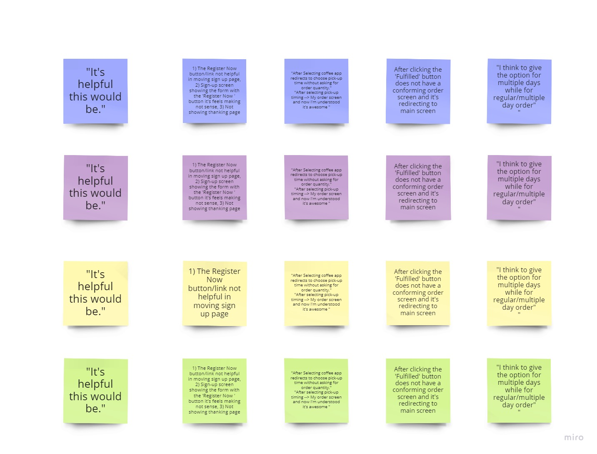
Affinity Diagram

